Advanced JUnit Testing Exercises

Exercise 1: Parameterized Tests Scenario:
You want to test a method that checks if a number is even. Instead of writing multiple test cases, you will use parameterized tests to run the same test with different inputs.
Steps: 1. Create a new Java class `EvenChecker` with a method `isEven(int number)`.
2. Write a parameterized test class `EvenCheckerTest` that tests the `isEven` method with different inputs.
3. Use JUnit's `@ParameterizedTest` and `@ValueSource` annotations.

SOLUTION:

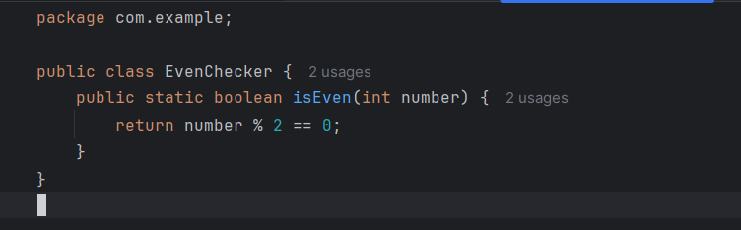
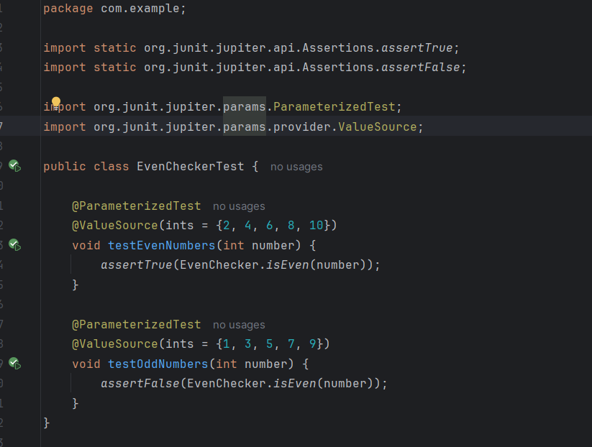

OUTPUT:

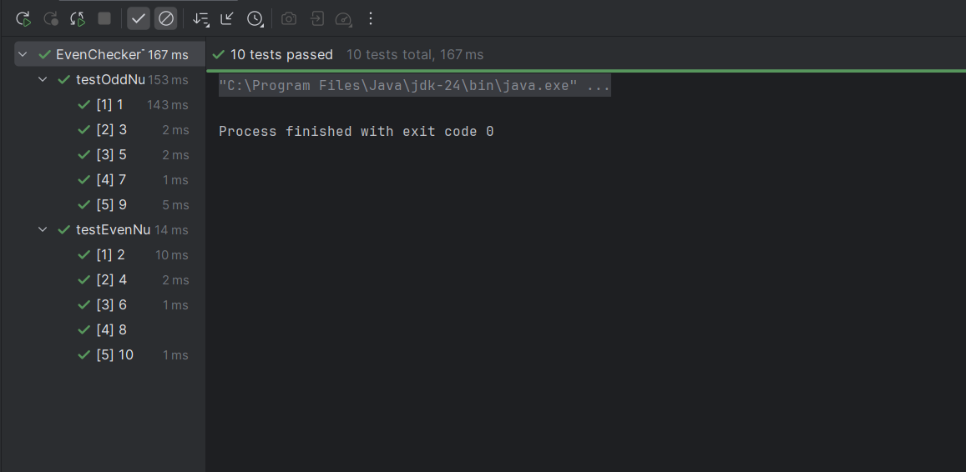

Exercise 2: Test Suites and Categories Scenario:
You want to group related tests into a test suite and categorize them.
Steps: 1. Create a new test suite class `AllTests`.
2. Add multiple test classes to the suite.
3. Use JUnit's `@Suite` and `@SelectClasses` annotations.
SOLUTION:
Calculator.java:
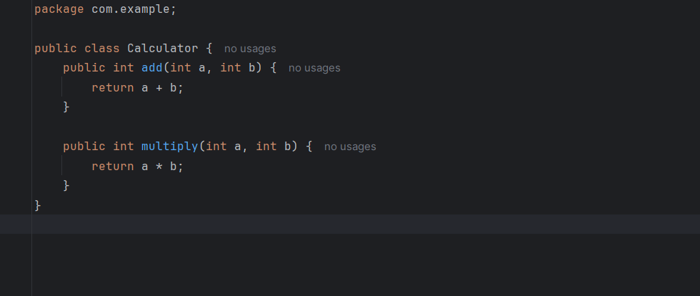
AllTests.java:
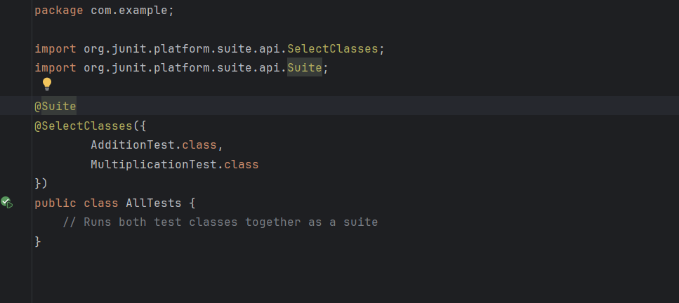

AdditionTest.java:
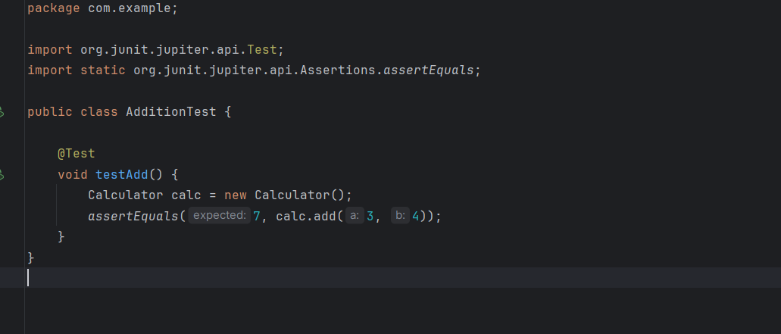
MultiplicationTest.java:
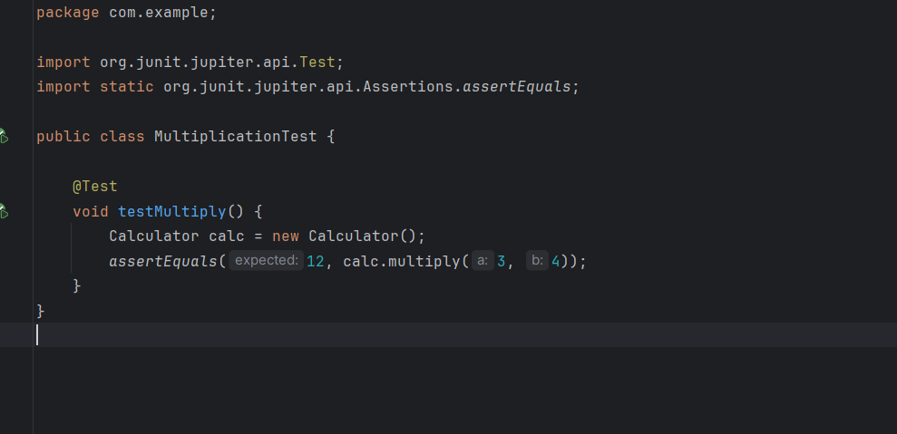
OUTPUT:
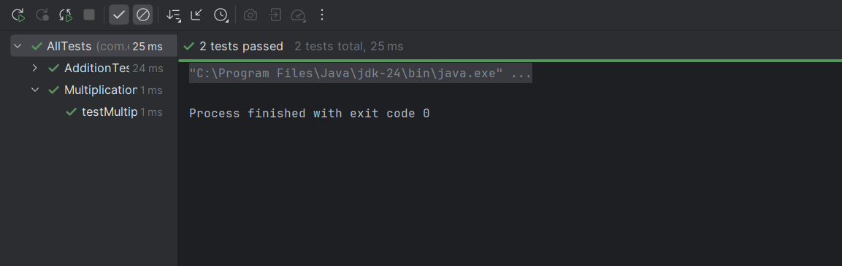

Exercise 3: Test Execution Order
Scenario: You want to control the order in which tests are executed.
Steps: 1. Create a test class `OrderedTests`.
2. Use JUnit's `@TestMethodOrder` and `@Order` annotations.
SOLUTION:
MessageService.java:
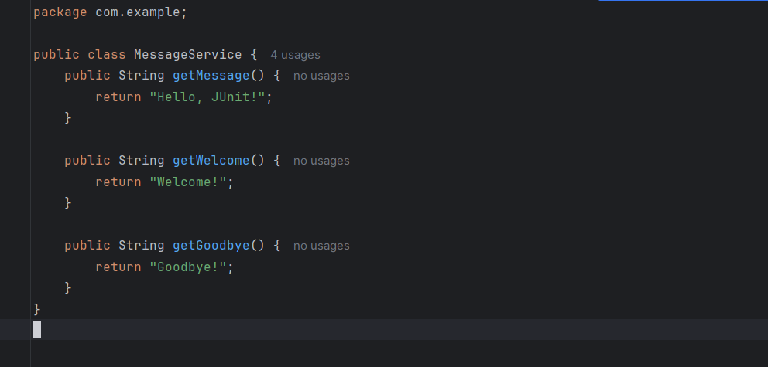
OrderedTests.java:
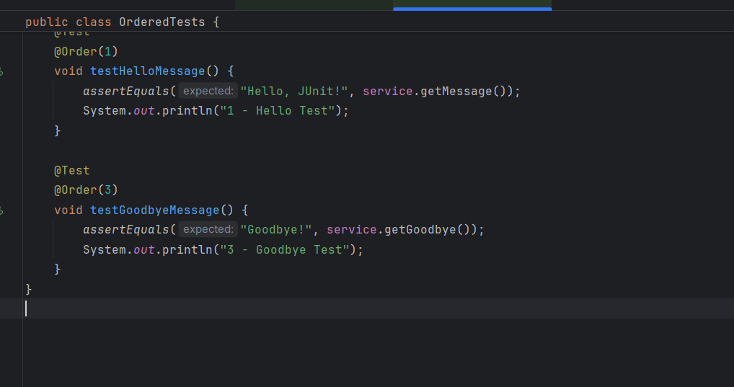

SOLUTION:
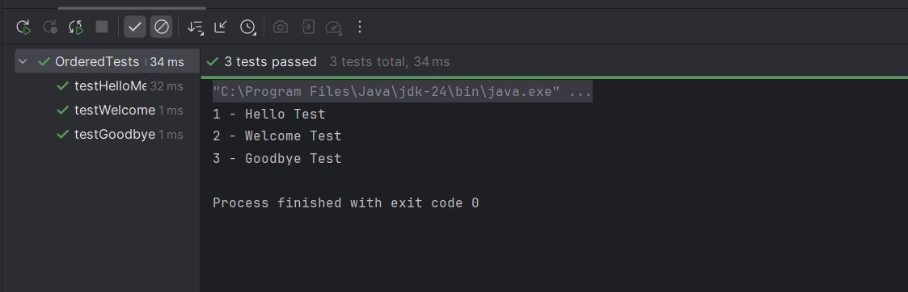

Exercise 4: Exception Testing
Scenario: You want to test that a method throws the expected exception.
Steps: 1. Create a class `ExceptionThrower` with a method `throwException`.
2. Write a test class `ExceptionThrowerTest` that tests the method for the expected exception.
SOLUTION:
ExceptionThrower.java:
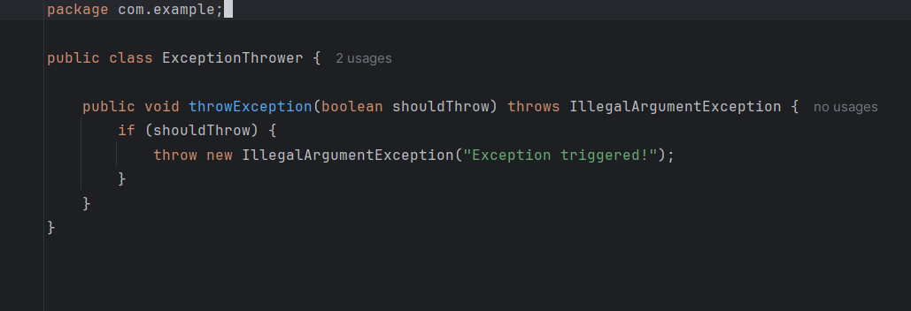

ExceptionThrowerTests.java:
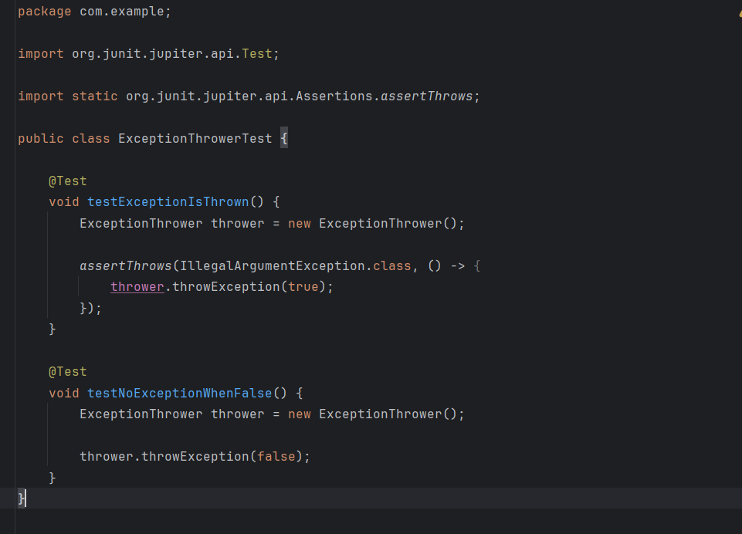

SOLUTION:

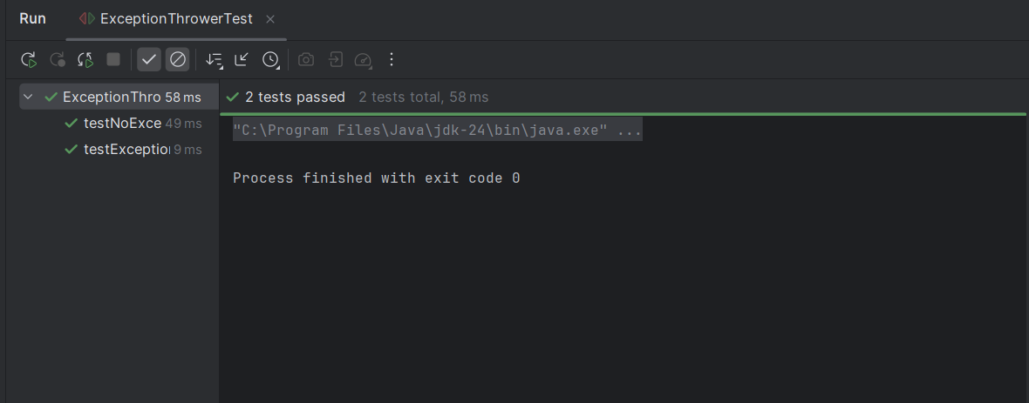

Exercise 5: Timeout and Performance Testing
Scenario: You want to ensure that a method completes within a specified time limit.
Steps: 1. Create a class `PerformanceTester` with a method `performTask`.
2. Write a test class `PerformanceTesterTest` that tests the method for timeout.
SOLUTION:
PerformanceTester.java:
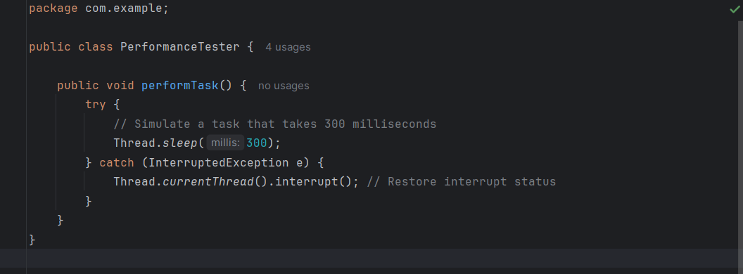
PerformanceTesterTest.java:
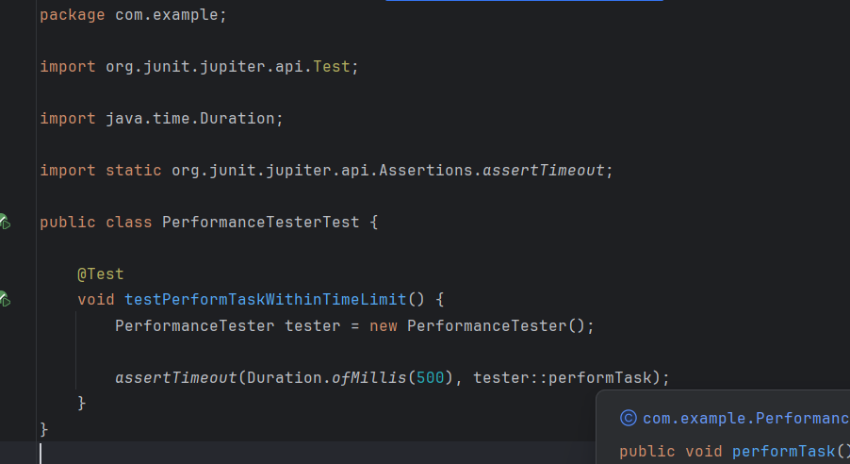

OUTPUT:
